When do Hippos Play?
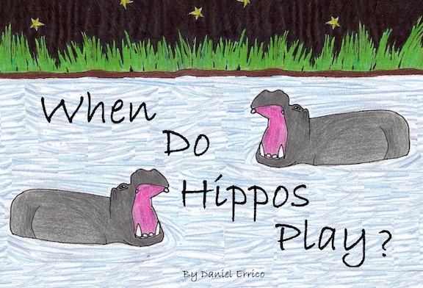
by Daniel Errico

By the African river, known as the Nile
The sun fell away and it rested a while

The rhinos had braved all the heat
They lay down to sleep as they wiped off their feet
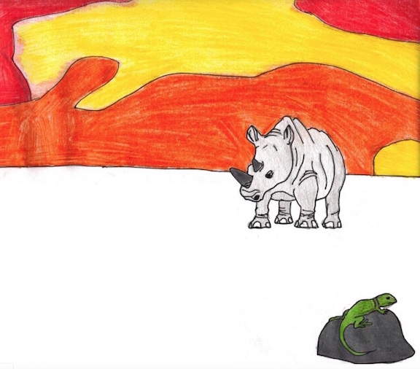

The elephants marched to their elephant beds
And gently they rested their elephant heads

The hippos went bathing in cool, shallow pools
Thinking the rhinos and elephants fools

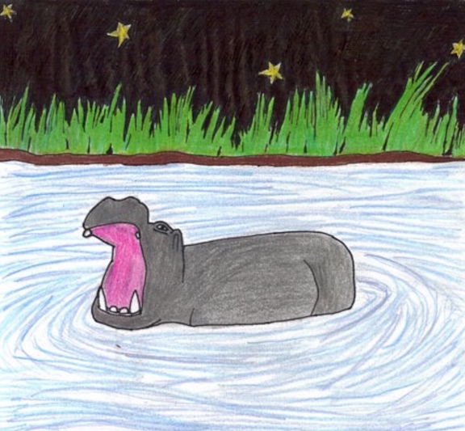
Slowly the hippos sank into the river
The water so cold that it gave them a shiver

(Hippos can't swim, like the pelicans think
They also can't float, they could easily sink)

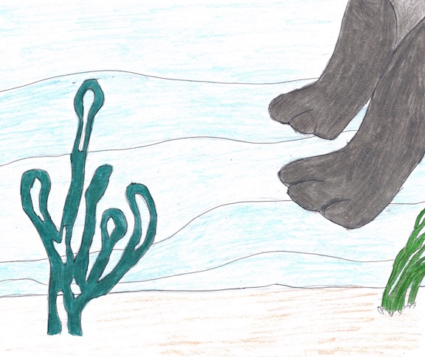
Underwater, they fell to the soft river bed
On darkish green plants with a smidgen of red

They strolled on the bottom, then bounced up for air
They did it for hours, without any care
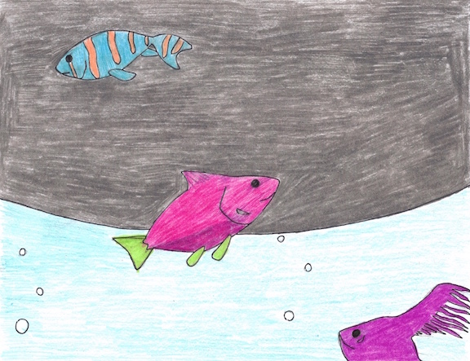
The fish followed closely, and wove in an out
Under their belly, and up to their snout

Each of the hippos came up to the shore
To feed on the grass by the river once more

They dried off their bodies by shaking and stomping
And took bites of grass, chewing and chomping
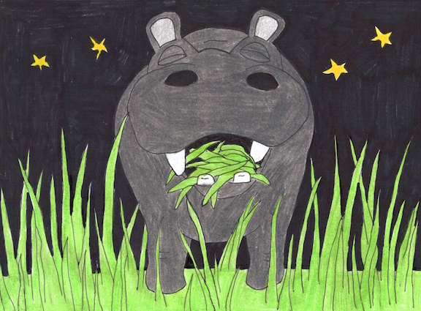
With night fading fast, they were full from the feast
The sun returned back, rising up from the east
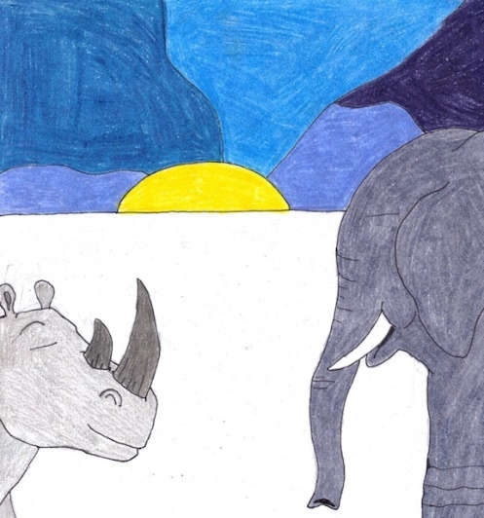
The hippos crept off to collapse for the day
While rhinos and elephants got up to play

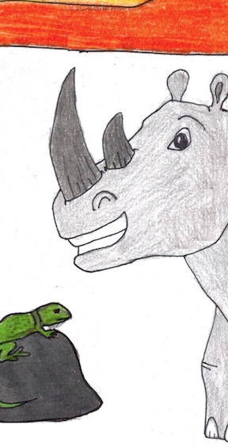
Enjoying the warmth of the sun and its light
Never knowing the story of hippos at night
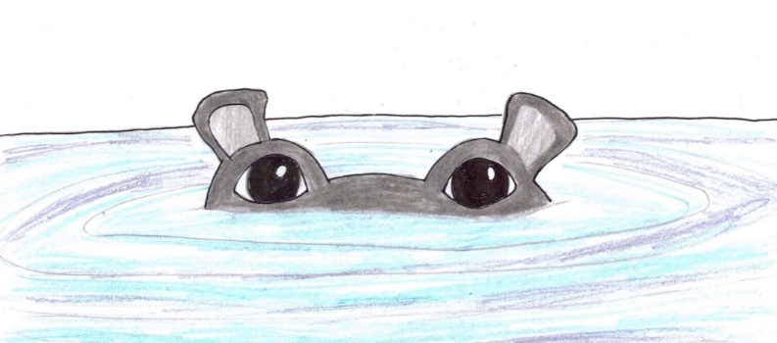
THE END

Post-Reading Task
1. Vocabulary
For each bolded word from in the story, write down its Part of Speech (noun, verb, adjective, adverb, preposition, conjunction) and its meaning in the following table. Some examples are shown.
Word | Part of Speech | Definition / Meaning
rhino (rhinoceros) | noun | A very large, thick-skinned animal from Africa that has one or two horns on its nose.
brave  (had braved) | verb | To show courage.
shallow
sink (sank)
shiver
pelican
float
river bed
darkish | adjective | Something that is of dark or black color.
smidgen
stroll
weave (wove)
snout
Shore
stomp (stomping)
feast
creep off (crept off)
2. Questions about the story
1) What did the hippos brave?

2) Where do hippos bathe?

3) Can hippos float?

4) What does a 'smidgen of red' mean?

5) What do hippos feed on?

